## Installing Active Directory on Windows Server 2012 R2

In this article, I will be covering the steps to install “Active Directory” on Windows Server 2012 R2 using Server Manager. First, it is required to install “Active Directory Domain Services” on the Windows Server. Then the server should be promoted as a “Domain Controller”.

In **Server Manager**, go to **Manage**, and click **Add Roles and Features**. It opens the **Add Roles and Features Wizard**. Click **Next**.

**Note:** If you have previously selected to skip this page by default, you will be going to the next page directly

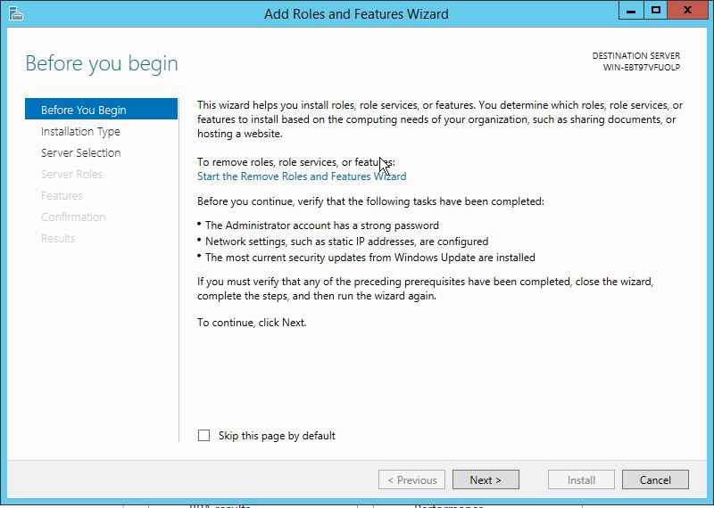

In **Select Installation Type**, select **Role-based or feature-based installation**and click **Next**.

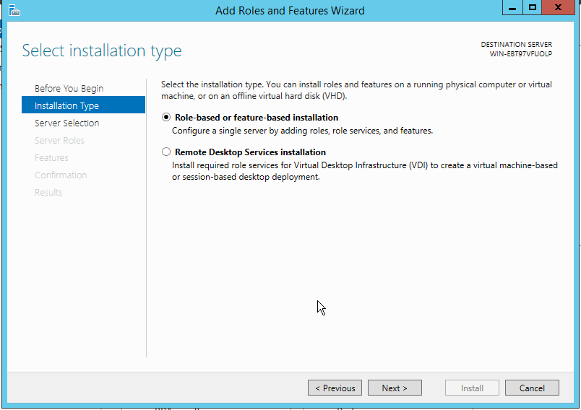

Select “**Select a server from the server pool**”. In **Server Pool,**ensure that the local computer is selected and click **Next.**

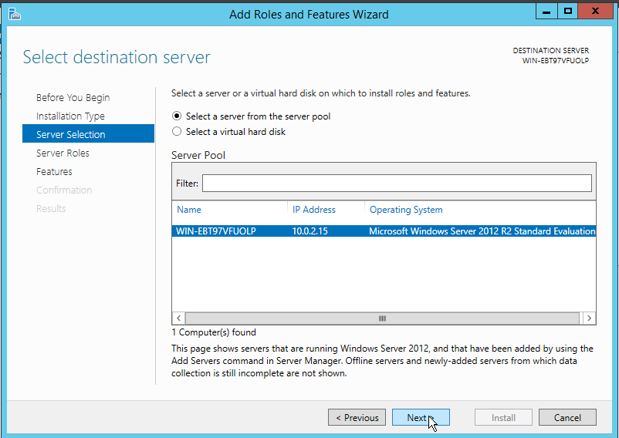  
Select **Active Directory Domain Services**from **Roles.**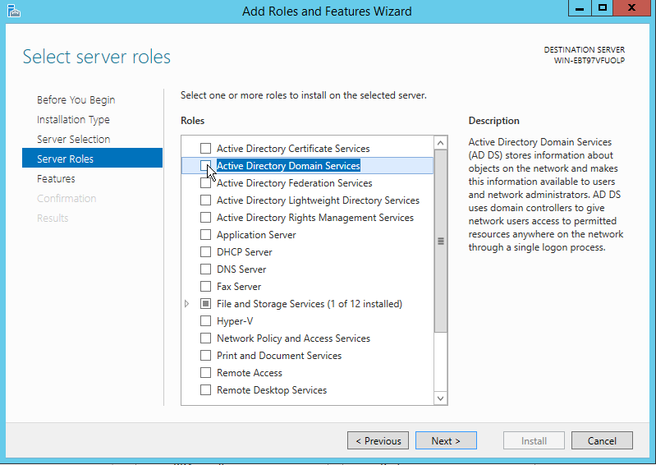You will be prompted to add required features. Click **Add Features**and then click **Next.**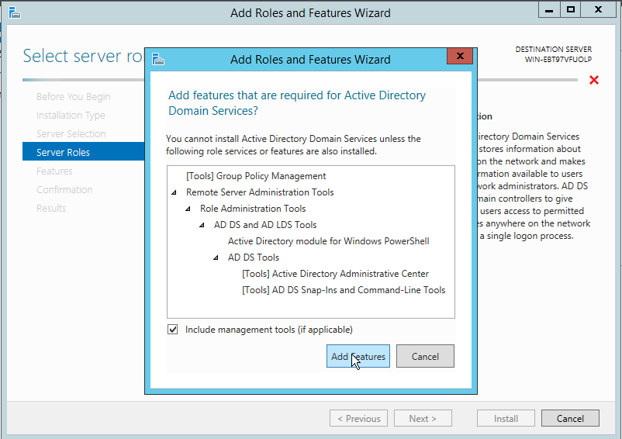In **Features,**select **Next.**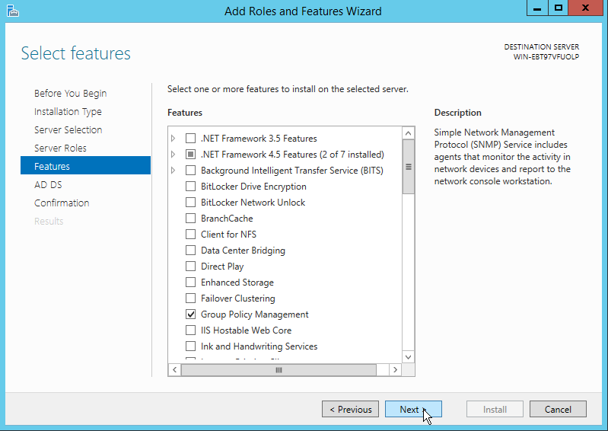Read the information in **Active Directory Domain Services**page and click **Next.**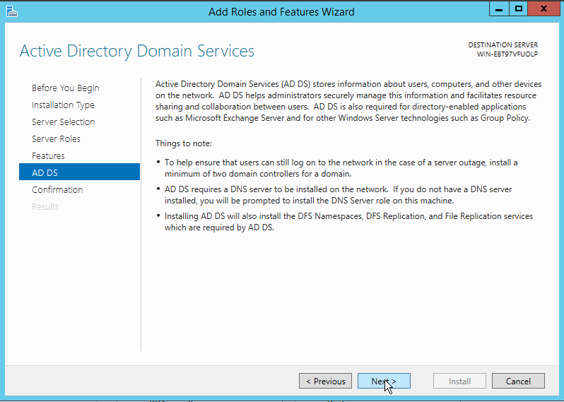In the **Confirmation**page, click **Install**to install the roles, role services, or features on the server.  
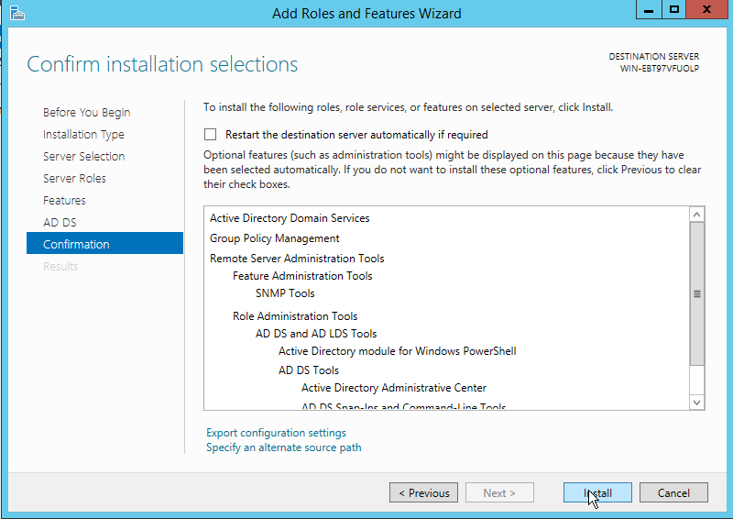  
The installation process will start. You may **close**the wizard.  
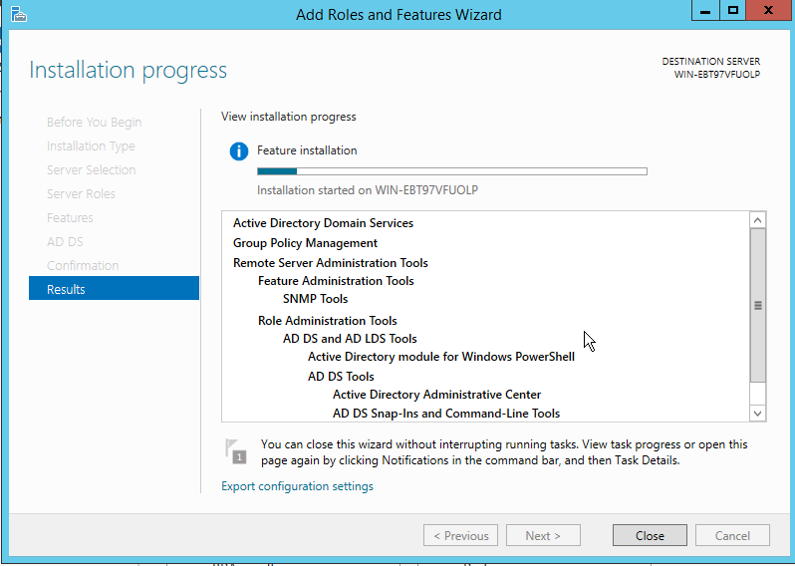  
When the installation is completed, click on **Notifications**in **Server Manager**, and click on the link **Promote this server to a domain controller**.  
  
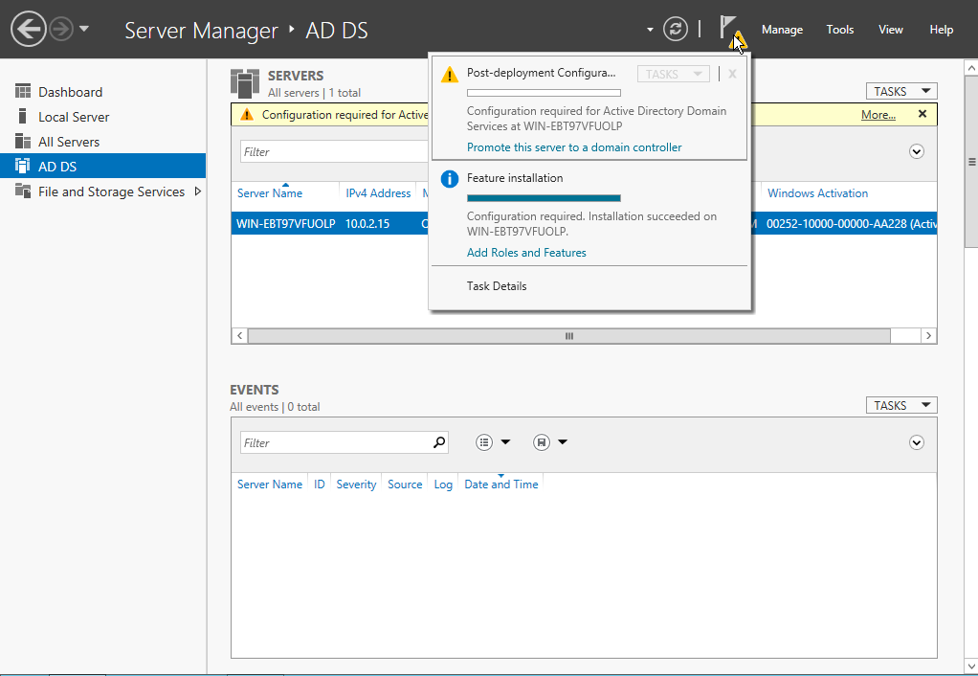  
When the **Active Directory Domain Services Configuration Wizard**opens, select **Add a new forest**and enter **Root domain name**. Then click **Next.**

(**Note:**The provided instructions in this article are for installing a new forest. If you are installing an additional domain controller in an existing domain or installing a new child domain or installing a new domain tree, refer to Windows Server Docs available [here](https://github.com/MicrosoftDocs/windowsserverdocs/blob/master/WindowsServerDocs/identity/ad-ds/deploy/Install-Active-Directory-Domain-Services--Level-100-.md#BKMK_GUI) for more information.)  
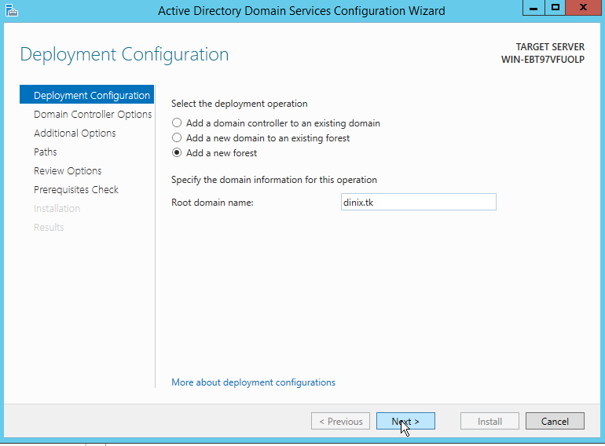  
In Domain Controller Options, leave **Forest functional level** and **Domain functional level**as default. Leave **Domain Name System (DNS) server**checked. Provide a password for **Directory Services Restore Mode**and click **Next.**

(**Note:**DSRM password is required when booting the domain controller into recovery mode)

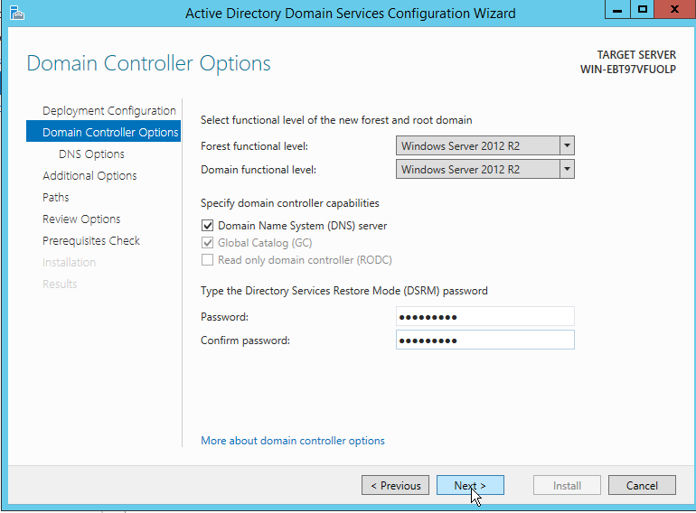  
Ignore the warning given in DNS Options page. Click **Next.**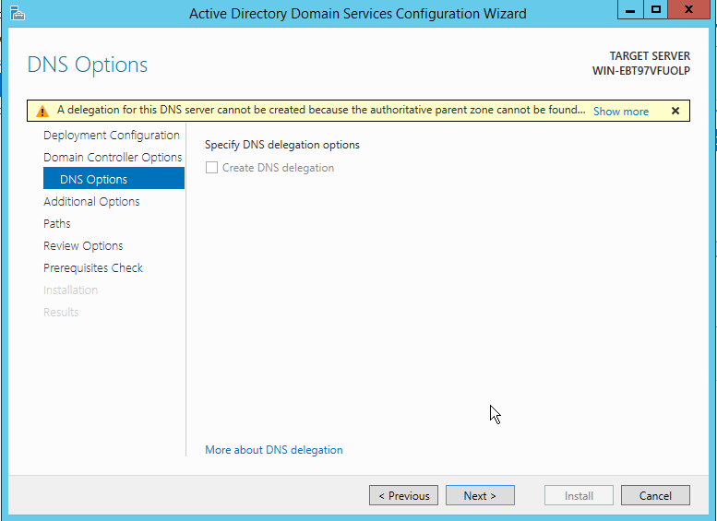Verify **NetBIOS domain name**. Click **Next.**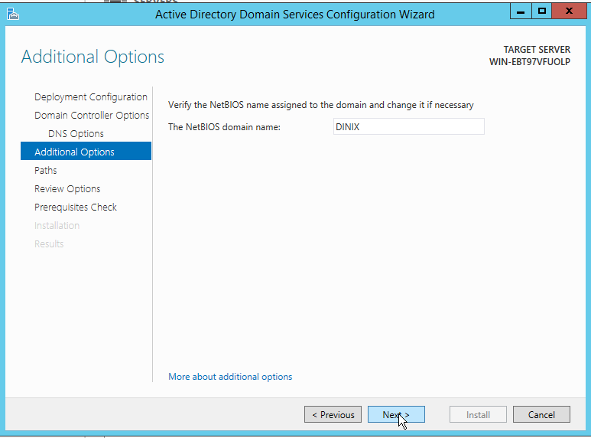Specify locations for **AD DS Database folder, Log Files folder,**and **SYSVOL folder.**

(Note: It is recommended to leave these as defaults). Click **Next.**

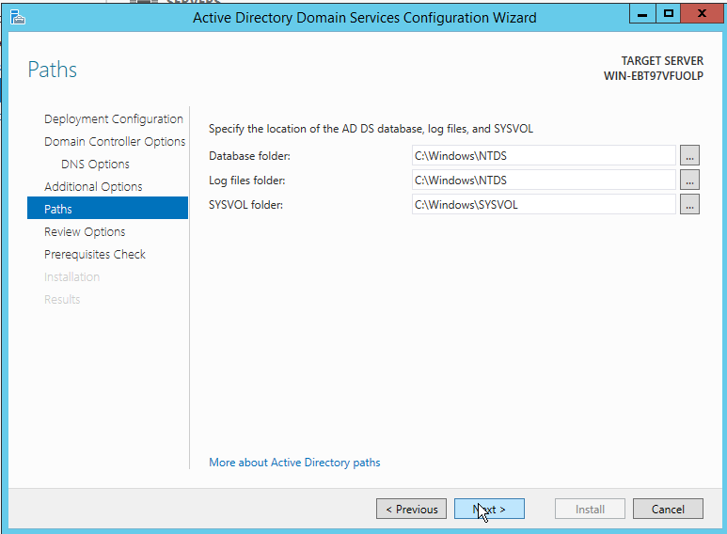  
Review your selections and click **Next.**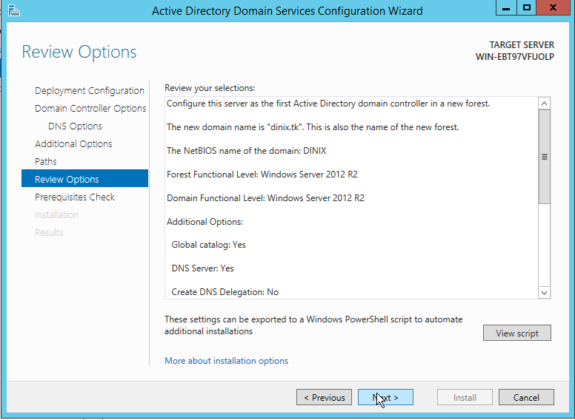The wizard will validate the prerequisites before installing AD DS. When all checks are passed successfully, click **Install.**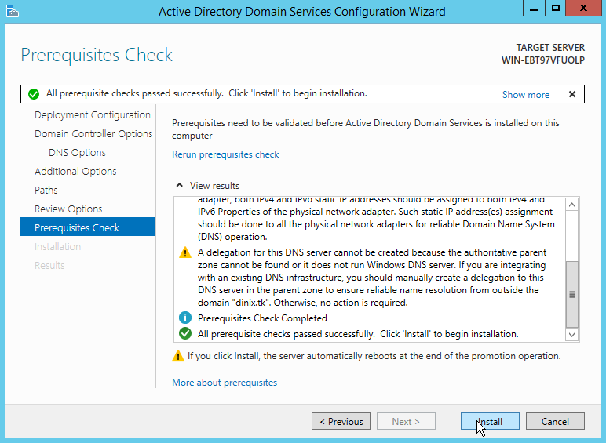The installation will be started.  
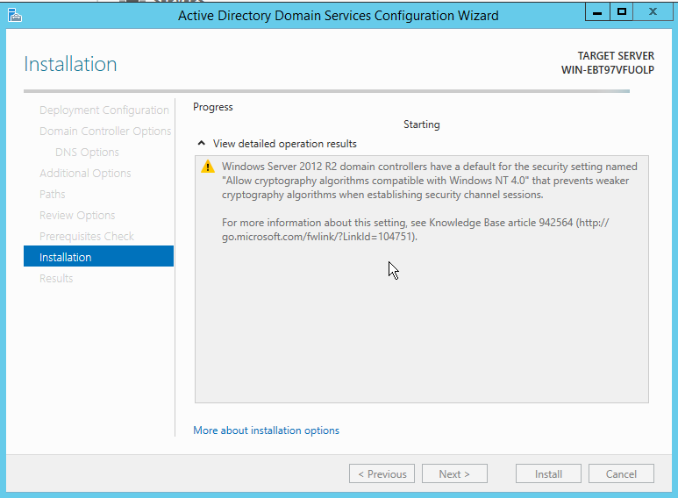  
When the installation is completed, click **Close**to finish the wizard.  
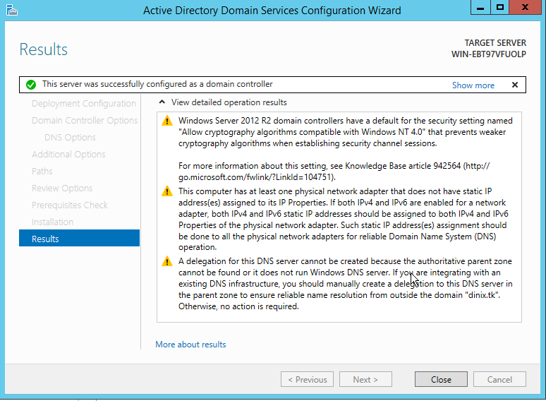  
Active Directory Domain Services have been successfully installed. Your machine will be rebooted automatically.  
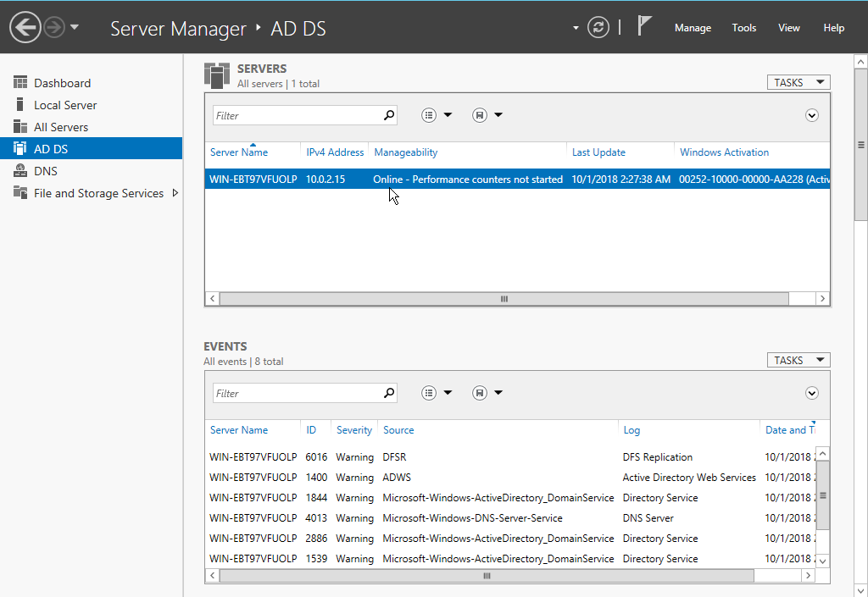  
Now you have set up Active Directory on your Windows Server 2012 R2 successfully. You can use **Active Directory Users and Computers**tool to access your newly created active directory.